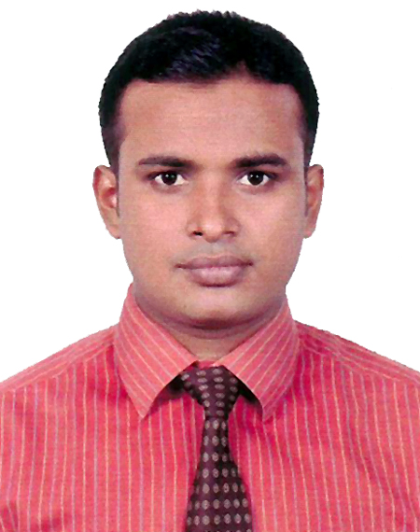

CU

CURRICULUM VITAE
MUSLIM SUB PARVEZ
House-704, Taltola, Boro Mogbazar, Dhaka-1217
Cell: +8801713-601612,
Email: parvezbd111990@gmail.com

Career objective

- To build up my career in the field of some challenging post in any organization
where there is immense scope to work and prove one’s expertise and maneuver
positive contribution in the organization by sincerely accomplishing the duties
and responsibilities assigned to me.

Academic Qualification

Master of Business Studies (M.B.S):
Institute : Noakhali Govt. College
Affiliated : National University, Bangladesh.
Subject : Accounting
Passing Year : 2017
Result : CGPA - 2.44 (Out of 4.00)
Bachelor of Business Studies (B.B.S):
Institute : Noakhali Govt. College, Noakhali.
Affiliated : National University, Bangladesh.
Subject : Accounting
Passing Year : 2012
Result : 2nd Class
Higher Secondary School Certificate (H.S.C):
Institute : Banderhat Abdul Malek Degree College.
Group : Business Studies
Board : Cumilla
Passing Year : 2009
Result : G.P.A- 2.70 (Out of 5.00)
Secondary School Certificate (S.S.C):
Institute : Rambollovpur High School
Group : Business Studies
Board : Cumilla
Passing Year : 2007
Result : G.P.A- 3.13 (Out of 5.00)

Other Personal details

Father’s Name : Mohammad Yousuf
Mother’s Name : Umme Kulsum
Date of Birth : 01/01/1990
Nationality : Bangladeshi (By Birth)
Religion : Islam
Marital Status : Single
Permanent Address : Dr. Yousufer Bari, Vill- Dadpur, P.O - Rambollovpur,
P.S: Noakhali Sadar, Dist: Noakhali.

WORK EXPERINCE

1. Designation : Assistant Officer
Company Name : Globe Janakantha Shilpa Paribar Ltd.
Location : Dhaka
Duration : 07 May 2016 till Now

Duties/Responsibilities:
- Maintain Utility bills payment processes, cheque withdraw, Transfer, clearance and other banking activities.
- Take orders from supervisors for maintenance and repair of PABX systems and buildings.
- Assist mechanics and other technical staff in testing and repairing utility systems.
- Assist purchase activities and others.

LANGUAGE ABILITY

- Bengali (Native)
- Medium command in writing & spoken English.

Computer Skills

- MS office programs (Word, Excel, PowerPoint).
- Capable of grab facilities of Internet.

Self Assessment

- Excellent negotiation, interpersonal communication skills.
- Being able to interest with people at all levels & work as a team player.
- Like to take challenges & ready to work under pressure.
- Self-motivated & optimistic by nature.

References

- Md.Nur Nobi
PA to Hon’ble Minister
Ministry of Industries
91, Motijheel C/A,Dhaka-1000.
Mobile:01712-223138

- Md.Shahjahan (Bachchu)
General Manager (HRD)
Globe Janakantha Shilpa Paribar Ltd.
24/A,Rashed Khan Menon Road, New Eskaton, Dhaka-1000.
Mobile: 01711-643158

Declaration

I do declare that all the above information is true and correct to the best of my knowledge.


---------------------
Date: Signature

